Information Technology PAT



Caleb Eloff
Grade 11SR
Protea Heights Academy

TASK 1A: Define the Task

Thoughts without actions. Ideas without plans. It’s always nice to say ‘Oh I will do this tomorrow’, ‘This is what I want to do next year’, ‘I will achieve this next month’, but in actuality without taking the time to fully flesh out those ideas, without a plan, those ideas almost never become reality.

The same applies for those who wish to work out. That is where the RedExercise program comes in.

The application aims to facilitate a healthier lifestyle by providing users with a personalized workout management system. Modern life demands convenience, yet staying fit requires dedication and structured planning. Many individuals struggle to keep track of their workout routines, find reliable exercise programs, and maintain motivation. This is where our project steps in.

The solution will be a Delphi-based offline application, which stores all user data, workouts, and schedules in a local database. Users will be able to sign up, log in, and access various workout plans tailored to their fitness goals. The application will enable users to select, personalize, and track their workouts. It will also provide motivational images and progress tracking features to keep users engaged and motivated.

Users can select their focus areas (e.g., arms, chest, abs, legs) and main fitness goals (e.g., losing weight, building muscle, keeping fit). The application will then generate a personalized workout plan, which users can follow and update as needed. They can mark workouts as completed and view their progress over time. Administrators will have additional functionalities to manage user accounts and workouts, ensuring that the system remains up-to-date and effective.

The scope of this project is limited to developing a user-friendly, offline workout management system using Delphi, with all operations stored in a local database. Extensive planning and time management are critical to ensure the successful completion of this project by the due date. The solution addresses the need for structured, personalized fitness routines, helping users stay on track and achieve their fitness goals.

TASK 1B: User story and acceptance

User Type | Role | Activity | Limitations
Customer | Standard users looking to manage and personalize workouts. | Creates a new account. | Must provide valid  details.
 |  | Login to their account | Must enter the correct  email and password.
 |  | View, search, filter, and sort workouts. | None
 |  | Add workouts to their  schedule. | Can only add workouts  that are available.
 |  | Mark workouts as  completed. | None
 |  | Remove/change  workouts in their  schedule. | Cannot add workouts  beyond the available  list.
 |  | View their workout  history and progress. | Can only view their own history.
Administrator | Users who manage  workouts and user accounts. | Login to their account. | Must enter the correct  username and  password.
 |  | Add new workout  listings. | Must provide valid  workout details.
 |  | Update existing workout  listings. | The updated details must be valid.
 |  | Remove existing  workout listings. | None
 |  | View users' workout  schedules. | Cannot edit the  schedules.
 |  | View users' progress  and workout history. | Cannot edit the  progress history.
 |  | Manage user accounts. | Cannot delete admin  accounts.
 |  | View overall app usage statistics. | None

User Stories

Customer
- As a customer, I want to create a new account so that I can manage my workouts and track my progress.
- As a customer, I want to log in using my email and password so that I can access my own personal account.
- As a customer, I want to be able to create workouts that can be added to my schedule.
- As a customer, I want to mark workouts as completed so that I can track my progress.
- As a customer, I want to remove or change workouts in my schedule.

Administrator
- As an administrator, I want to log in with my username and password so that I can access my admin account.
- As an administrator, I want to view users' workout schedules so that I can assist them if they encounter issues with the system.
- As an administrator, I want to manage user accounts so that I can help users troubleshoot issues.

TASK 2: Data Dictionary
Located in attached DataDictionary Excel file.

Example:
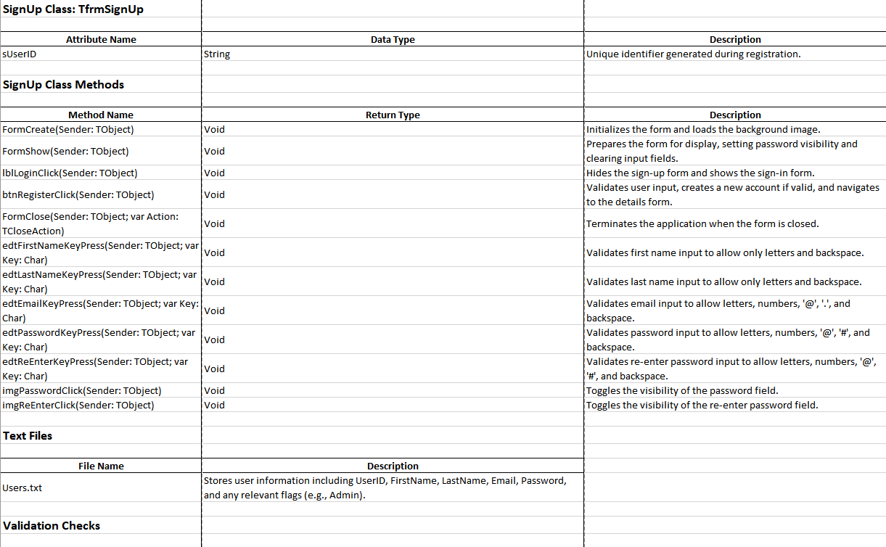

TASK 3: Database design

PK = Primary Key

FK = Foreign Key

tblAccounts
Field Name | Data Type | Example
UserID | Short Text | calelocje9921
FirstName | Short Text | Caleb
LastName | Short Text | Eloff
Email | Short Text | caleb@gmail.com
Password | Short Text | BadPassword123
Admin | Yes/No | Yes

tblDetails
Field Name | Data Type | Example
UserID | ShortText | calelocje9921
Gender | ShorText | Male
Arms | Yes/No | Yes
Chest | Yes/No | Yes
Abs | Yes/No | Yes
Legs | Yes/No | No
LoseWeight | Yes/No | No
BuildMuscle | Yes/No | Yes
KeepFit | Yes/No | No
Days | Number | 7

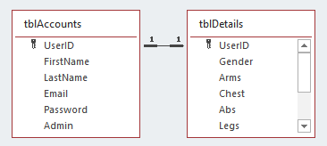

.

TASK 4: Navigation (GUI Design)

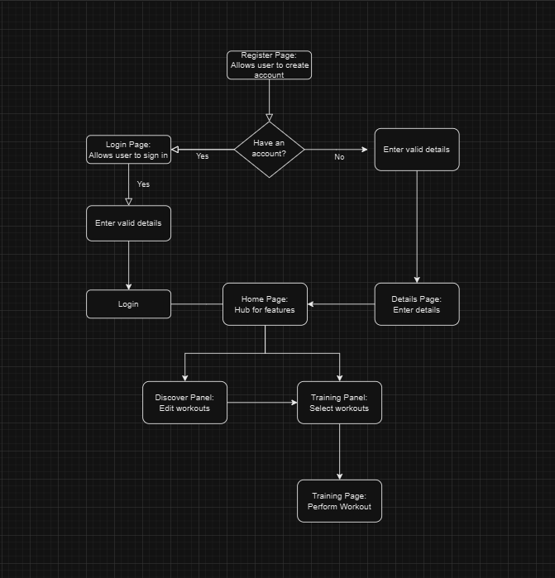

frmSignUp

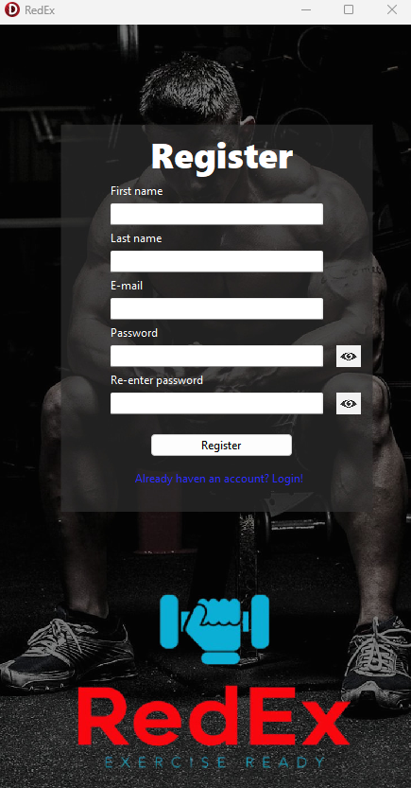

frmLogin
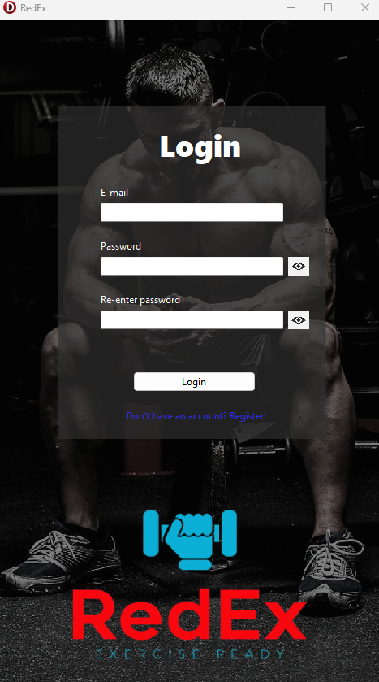

frmHome
